**TRX Training & Weight Room**

*Freshman Physical Education*

**What is Fitness?**

A combination of physical and mental attributes that allow you to: Meet the demands of everyday life and perform tasks that require more than the normal amount of effort.Being physically and mentally fit decreases the chance of injury or bodily harm.  Most importantly it can improve your quality of life.

There are 5 parts of fitness:

1. Cardiovascular Endurance
2. Muscular Strength
3. Muscular Endurance
4. Flexibility
5. Body Composition.

**5 COMPONENTS OF FITNESS**

**CARDIOVASCULAR ENDURANCE**

* The most important part of fitness!!!  Having conditioned heart & lungs that can supply the body with oxygen without stress to the heart.
* We develop it by doing Aerobic Exercise.  Aerobic Exercise is continuous exercise lasting 2 or more minutes.  In order to improve cardiovascular endurance, aerobic exercise should be performed at least 3 times per week, 15-20 minutes each day.
  + Examples of aerobic exercise: swimming, running, biking, shoveling snow, raking leaves, etc.

**MUSCULAR STRENGTH**

* The amount of force produced by a muscle.  Needed for activities that require above normal effort.  Having poor muscular strength will increase the chance of getting hurt when doing activities that require more than the normal amount of effort.
* To increase your muscular strength, you would perform exercises using heavy weight and do the exercise 3-6 times.  The muscles get stronger when they keep working past the point of fatigue (when the muscle has very little or no energy left).  This forces the body to adapt (muscles get used to doing something, what was hard is now easy for the muscle).

**MUSCULAR ENDURANCE**

* The amount of force produced by a muscle over a period of time.  This is also if the muscles are doing something over and over and over.  Muscular endurance is also closely related to cardiovascular endurance.  Why? Because in order to perform aerobic exercises long enough (at least 15 minutes) to benefit the heart and lungs, you need muscular endurance to be able to exercise continuously for this long.
* We improve muscular endurance by using lightweight and do the exercise at least 15 times.

**FLEXIBILITY**

* This is looseness or elasticity of a muscle, which allows the joint to move through a full range of motion.  This is the most neglected part of fitness.
* Flexibility is affected by gender, age, size and condition of muscle & level of activity.
* Muscles should always be warmed (by cardio) before they are stretched.
* Poor flexibility increases risk of injury.

**BODY COMPOSITION**

* The percentage of body fat compared to lean body tissue.  Lean body tissue is: muscle, bone, water & organs.  If a person’s body fat percentage is not in the 5-30% range, this could become a health concern.
* Your weight on the scale means nothing unless you know your body fat percentage.
* Don’t be mislead by height/weight charts, as they are inaccurate.

**WEIGHT ROOM & WELLNESS CENTER**

**Safety Rules**

* Use locks/clamps on the ends of the bars.
* Do not lean against equipment or walls.
* Return dumbbells to the rack in their proper order.
* Do not drop weight plates or dumbbells.
* Use spotters for necessary exercises.
* Report any facility-related injury, or facility or equipment irregularity to teacher.
* Do not wear jewelry such as loose necklaces, bracelets, hanging earrings, or watches.
* No Horseplay at any time
* Do Not Sit on the Various Lifting Apparatus during your Rest Interval
* Wear Proper Lifting Clothes
* Shoes Must Be Worn at All Times (No Sandals or Open Toe Shoes)
* Do Not Slam the Weights on the Weight Machines
* A Spotter Must Be used on all Free Lifting Stations.  Example: Bench Press, Incline Press, Squats, Power Cleans, etc..
* Return all Free Weights to their Correct Weight Racks and or Weight Trees
* Never Lift Weights Without a teacher present In the room

**Weight Room & Wellness Center Etiquette**

* Always wipe machines down after use
* Return all equipment to its proper place. Re-rack weights and dumbbells appropriately.
* Please allow others to "work in" between sets. Do not monopolize the equipment.

**TRX TRAINING (SUSPESION TRAINING)**

**The Benefits of TRX Suspension Training**

1. It is great for all levels of athleticism and almost anyone can use it.
2. There are hundreds of exercises that can be used for all different goals ranging from:
   1. Speed
   2. Cardiovascular Endurance
   3. Muscular Endurance
   4. Agility
   5. Flexibility
   6. Injury Rehabilitation
3. “All core all the time” TRX requires you to constantly contact and engage the core keeping the body stable throughout the entire exercise.
4. It is a functional workout meaning that each workout is designed to help you out with daily activities.
5. It is very easy to make an exercise easier, or more difficult in two ways:
   1. Moving closer or further away from the anchor point.
   2. Changing your stance.

**Adjusting the Length of the Suspension Trainer**

*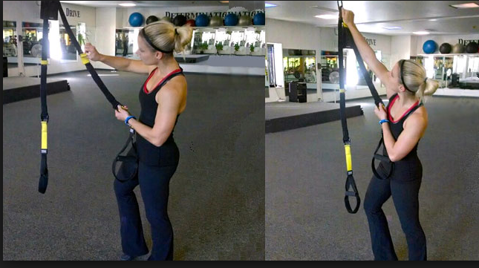To shorten the suspension trainer:*

* Hold one strap of the trainer, depress the cam buckle with your thumb and grab the adjustment tab (yellow) with opposite hand. .
* Pull the adjustment tab up along the straps. Then repeat on opposite side.

*To lengthen the suspension trainer:*

* Depress both cam buckles and pull down away from the anchor point.
* Make sure the straps are not twisted before adjusting.

**Suspension Trainer Length Adjustment**

There are five main length adjustment options available when using the TRX suspension trainer.

1. **L – Long:** Fully lengthened so that the bottom of each foot cradle is three inches off of the ground. (image 1)
2. **MC – Mid Calf:** Adjust the straps so that the bottom of the foot cradle is at mid-calf level. (image 2)
3. **ML – Mid Length:** Adjust the straps to mid length by positioning the tabs to the middle of the main strap. (Yellow tab to the gray line) (image 3)
4. **FS – Short:** Fully shorten the straps by positioning the tabs at the top of the mains trap. (image 4)
5. **OS – Over Shortened:** From the fully shortened position, depress the cam buckles and pull up on the outside of the strap until it is all the way to the top. (image 5)

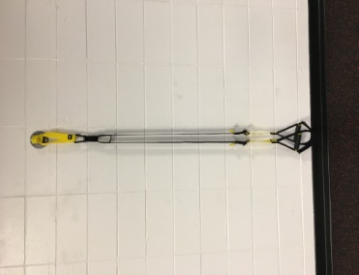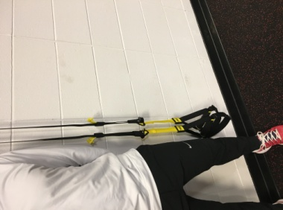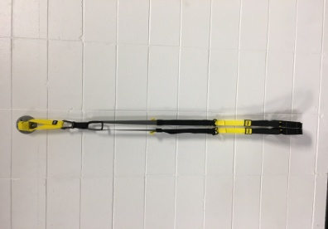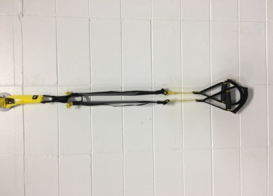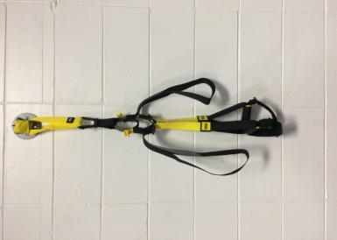

Image 1 Image 2 Image 3 Image 4 Image 5

**Changing the difficulty of the exercise**

There are two ways to changing the difficulty of the exercise. Changing the stance, or changing where you are in relation to the anchor point. (The anchor point is the location where the TRX suspension trainer is attached.)

Examples:

1. For a TRX Back Row you will be facing the anchor point, then walk backwards to create tension on the straps. The closer your feet are to the anchor point, the lower your body will be in relation to the ground, which makes the exercise harder. If your feet are far away from the anchor point, your body will be much more upright, thus making the exercise easier.
2. Changing your stance. There are four different foot positions that will increase or decrease the difficulty of the exercise.
3. Offset Stance - Easiest (image 1)
4. Wide Stance - Easier (image 2)
5. Narrow Stance - Medium (image 3)
6. One-foot Stance – Hardest (image 4)

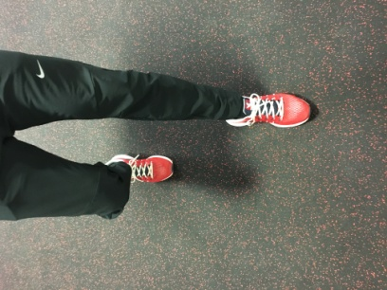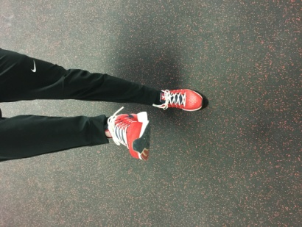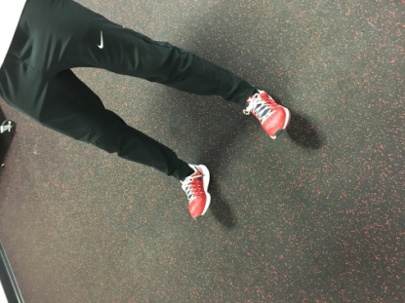

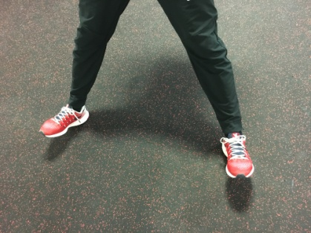

Image 1 Image 2 Image 3 Image 4